OFFICIAL COORDINATION REQUEST FOR
NON-ROUTINE OPERATIONS AND MAINTENANCE

COORDINATION TITLE - 22JDA01 NFL Stilling Well Replacement
COORDINATION DATE - February 17, 2022
PROJECT- John Day Dam
RESPONSE DATE – March 3, 2022

Description of the problem

The north fish ladder’s tailwater level sensor is giving faulty reading due to a broken stilling well pipe. This sensor automates pump controls that keep ladder attraction water in criteria. At 0600 hours on February 11th, 2022, John Day Fisheries personnel discovered the North Fish Ladder (NFL) was out of criteria (the NFL was in criteria at 4PM the previous day). The PLC showed a differential of 0.0’ instead of the FPP required 1-2’. An immediate investigation was performed, and Project Fisheries discovered the NFL stilling well pipe detached from the wall, fell into the ladder, and left the sensor free-floating in the channel (See figure 1). This led to incorrect sensor readings. The staff gauges were checked, and the NFL was running within the 1-2’ differential criteria. The control room was immediately notified, and the pumps were put in manual mode (3-pumps running at 190 RPMs). The channel sensor is necessary to ensure ladder differentials are kept within FPP requirements 24/7 and should be repaired to avoid any complications during the adult fish passage season.

The NFL has already undergone winter maintenance for the season and was returned to service January 21st, 2022. The remainder of the winter maintenance season will be needed to complete preventive maintenance and repairs on the South Fish Ladder (SFL). Additionally, the navigation lock outage has depleted any personnel that would otherwise be available for fisheries support (mechanics, electricians, crane operators, etc.). Therefore, Project Fisheries is requesting the ability to take the NFL out of service during the week of March 7th, 2022, to repair the channel sensor housing.

By waiting until the week of March 7th Project Fisheries will have all necessary personnel available to quickly repair the sensor housing. The week of March 7th also coincides with relatively low fish passage (see figures 1 and 2). The actual stilling well repair should only take 5-hours. However, the ladder may need to be operated at orifice flow (AWS pumps off) for 3-days to allow most fish to exit the ladder. This helps reduce fish handling which is less stressful for fish and personnel.

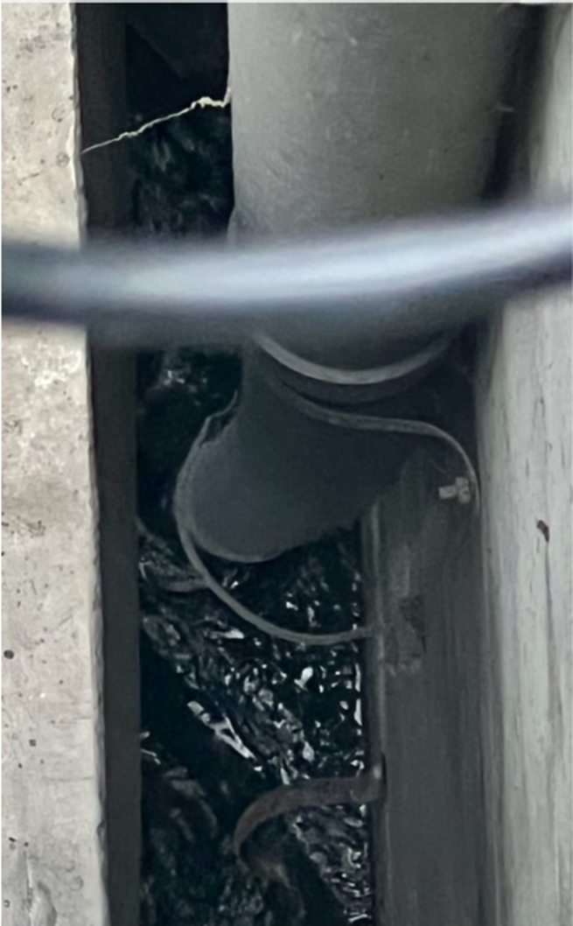
Figure 1.John Day north fish ladder AWS missing stilling well pipe.

Figure 2: Ten year average (2012-2021) daily steelhead passage at John Day Dam for the month of March.

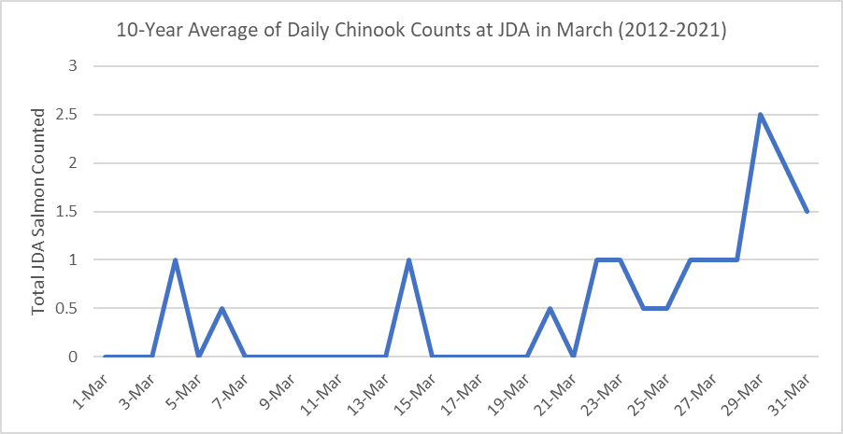Figure 3: Ten year average (2012-2021) daily Chinook passage at John Day Dam for the month of March.

Type of outage required

Impact on facility operation This will require the north fish ladder to be OOS for a maximum of 4-days during the week of March 7th, 2022. The south fish ladder will be in service and typically passes most salmonids at the JDA project.

Impact on unit priority this will NOT impact unit priority

Impact on forebay/tailwater operation This will NOT impact forebay/tailwater operations.

Impact on spill This will NOT impact spill operations, nor will it occur during spill season

Dates of impacts/repairs March 7th, 2022 – March 10th, 2022

Length of time for repairs 5-hours

Analysis of potential impacts to fish:
The north fish ladder will be OOS for 4 days so this will have some impacts on fish passage. However, the repairs are taking place during minimal fish passage most salmonids prefer to pass through the south fish ladder, which will remain in service.

Summary statement - expected impacts on:

Downstream migrants PIT data shows an insignificant number of juveniles pass down the north fish ladder. Additionally, this outage will occur before the actual smolt passage season when there have historically been very few outmigrants.

Upstream migrants (including Bull Trout) The ladder will be OOS for 4-days. Any upstream migrants (including Bull Trout) will be able to migrate up the SFL.

Lamprey Adult lampreys typically don’t show up at JDA until May so there should be no impacts to adults. Fish ladder use by juvenile lamprey is unknown.

Comments from agencies
WDFW
-----Original Message-----
From: Morrill, Charles (DFW) <Charles.Morrill@dfw.wa.gov>
Sent: Thursday, February 24, 2022 12:45 PM
Subject: [URL Verdict: Neutral][Non-DoD Source] RE: FPOM: Official Coordination - 22 JDA 01 MOC NFL OSS Stilling Well Replacement

Tammy et al.

I concur with Tom’s assessment. The sooner the better !

Charlie

CRITFC

From: Tom Lorz <lort@critfc.org>
Sent: Thursday, February 24, 2022 12:43 PM
Subject: Re: FPOM: Official Coordination - 22 JDA 01 MOC NFL OSS Stilling Well Replacement

External Email

While I am not excited about taking the ladder out in early March for 3-4 days, we can live with the outage given the need for the work. Adult numbers should be low and we have not started spilling yet. Anything you can do move this operation sooner would be appreciated.

thanks
Tom Lorz

NOAA Fisheries
-----Original Message-----
From: Blane Bellerud - NOAA Federal <blane.bellerud@noaa.gov>
Sent: Thursday, February 24, 2022 3:17 PM
To: Mackey, Tammy M CIV USARMY CENWP (USA) <Tammy.M.Mackey@usace.army.mil>
Subject: [URL Verdict: Neutral][Non-DoD Source] Re: FPOM: Official Coordination - 22 JDA 01 MOC NFL OSS Stilling Well Replacement

I already approved, but just in case. It is OK with me

Final coordination results

After Action update

Please email or call with questions or concerns.
Thank you,
Nathan

Nathan McClain
NWP Operations Division Fishery Section
Columbia River Coordination Biologist
Nathan.A.McClain@usace.army.mil

And

Scott Fielding
Chief of Fisheries
John Day Dam
Scott.D.Fielding@usace.army.mil

